When attempting to boot your Linux system, you see an error message and the system will not complete a normal boot. Which of the following could you type at the GRUB menu to enter a system admin mod for troubleshooting:

1 (s)(S)

The numeral 1 puts the system into runlevel 1, a troubleshooting mode. The character s or S also are used to put the system into a troubleshooting mode.

The system is having trouble and the engineer wants to bypass the usual /sbin/init start up and run /bin/sh. What is the usual way to pass this change to the kernel from your boot loader:

Pass init=/bin/sh on the kernel parameter line

Step 1: While standing on Grub’s menu, press e to edit

Step 2: Pass init=/bin/sh on the kernel parameter line

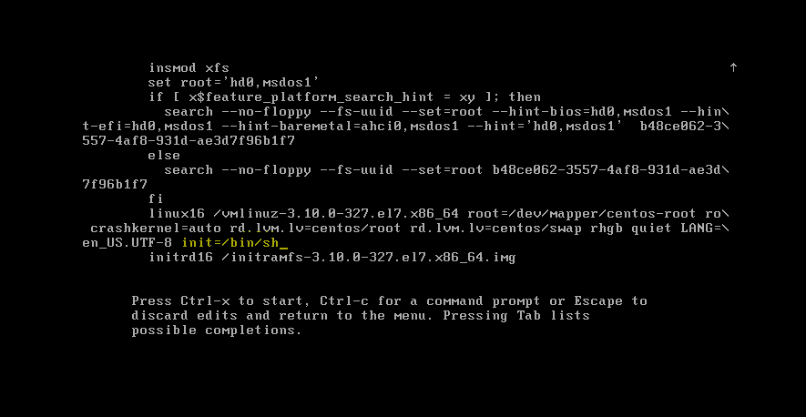

In case you use above method, you have to mount -o remount,rw / to write /etc/fstab or you can Boot in single user mode and correct the error where the local filesystems are not mounted.

i did it like this..  
1.boot with a instalation CD and go on to 'linux rescue' mode  
2. mount the root partition to some other path other than root (as it is already mounted)  
say mount on to /mnt/root  
3. and then i got the /etc/fstab editable.